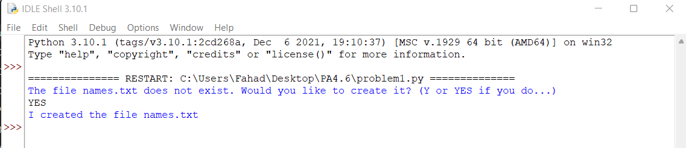

**Problem 1 (Output)**

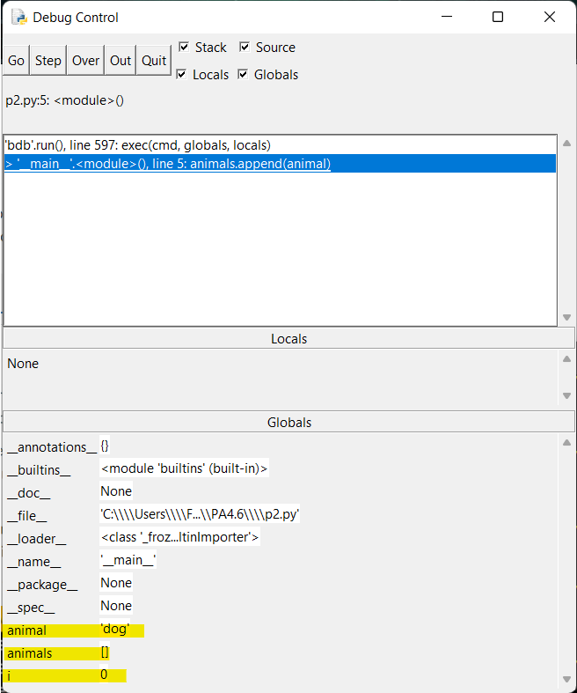

**Problem 2 (Debugger Window)**

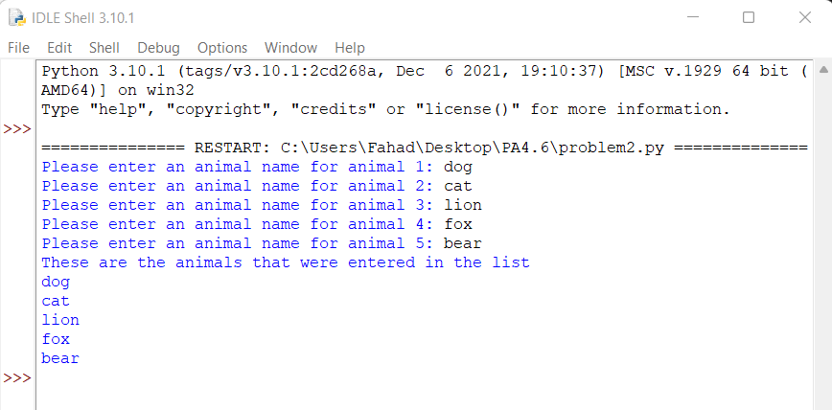

**Problem 2 (Output)**

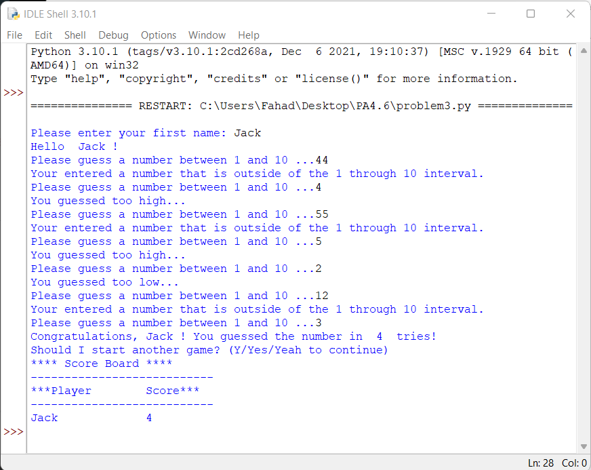

**Problem 3 (Output)**